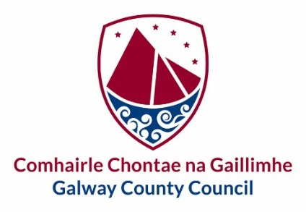
Oifig an Rúnaí,
Áras an Chontae,
Cnoc na Radharc,
Gaillimh.

12 Eanáir 2022

Chuig an gCathaoirleach and gach Ball den Choiste um Beartas Straitéiseach - Athrú Aeráide
agus Bithéagsúlacht

To: The Chairman and Each Member of the Climate Change and Biodiversity Strategic Policy Committee

A Chara,
Iarrtar ort bheith i láthair ag Cruinniú den Choiste um Beartas Straitéiseach - Athrú Aeráide agus Bithéagsúlacht, a bheith á reáchtáil trí Teams agus a thionólfar Dé Céadaoin an 19 Eanáir 2022 tosú ag 11.00 am.
You are hereby requested to attend a Meeting through Teams of the Climate Change and Biodiversity Strategic Policy Committee which will be held on Wednesday 19 January 2022 starting at 11.00 am.

Mise, le meas,

Maria Finn
Riarthóir Cruinnithe / Meetings Administrator
Tel. 087 9234911

C L Á R

- Confirmation of Minutes and Matters arising from Climate Change and Biodiversity Strategic Policy Committee Meeting held on 7 October 2021

- Biodiversity update

- Active Travel

- EV Charging points for the County

- Climate Action Plan

- Decarbonisation Zones

- AOB

- Date and Time of Next Meeting

